Kellen Haas
CPSC 2150
Project 1
9/19/20

Requirements Analysis

Functional Requirements

- As a user, I can choose which row I want to place my marker in.
- As a user, I can choose which column I want to place my marker in.
- As a user, I can view the game board before my turn and after my turn with my updated marker that I just placed.
- As a user, after the first user takes their turn, I can then choose my row.
- As a user, after the first user takes their turn, I can choose my column.
- As a user, I can expect that the system will notify me and my opponent if someone has won.
- As a user, I want to be notified by the system if there is a draw.
- As a user, if I choose a position where a marker already has been placed, the system will tell me that I cannot place a marker there.
- As a user, if I choose a position that is out of the bounds of the board, the system will tell me that it is not a valid position.
- As a user, I want to be able to view both mine and my opponents placed markers after every turn.
- As a user, I expect the top of the board to be the index 0, 0.
- As a user, I want to be asked after the game has ended if I want to play again.
- As a user, if I choose to play again, then the program should start over from the beginning and clear the game board.

Non-Functional Requirements
- The system must be coded in Java programming language.
- The system must be able to run on Unix/Linux.
- Program must be able to compile and run quickly and efficiently.
- The system must be written in IntelliJ IDE for debugging purposes in the future.

Design

Activity Diagrams

GameScreen.java
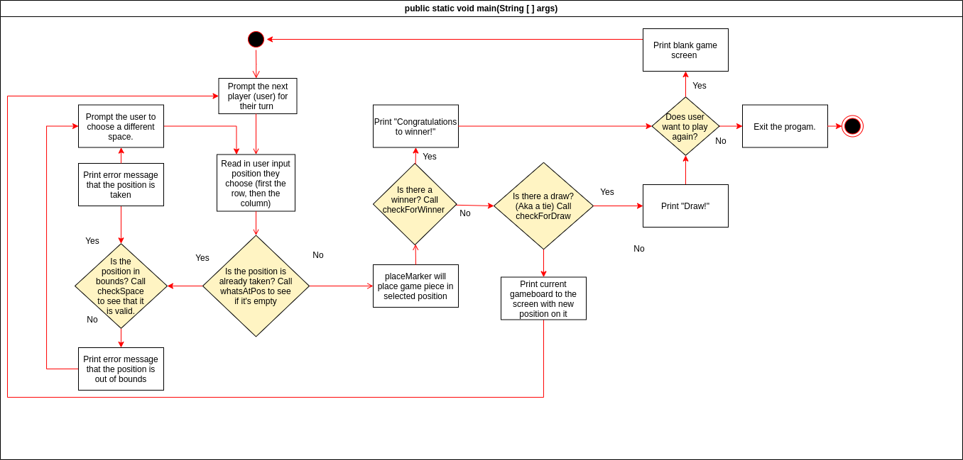

GameBoard.java

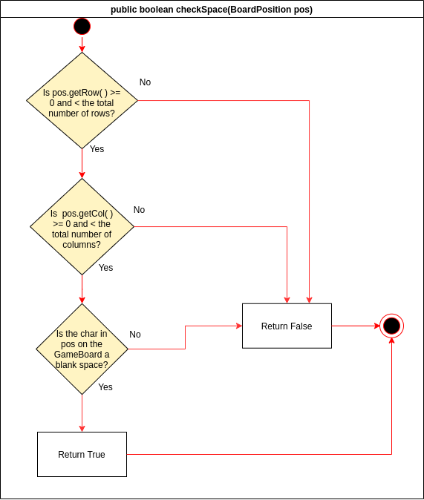

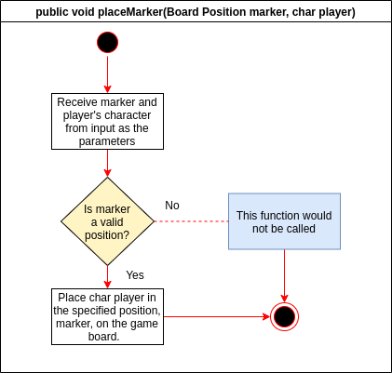

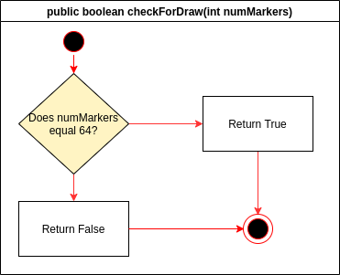

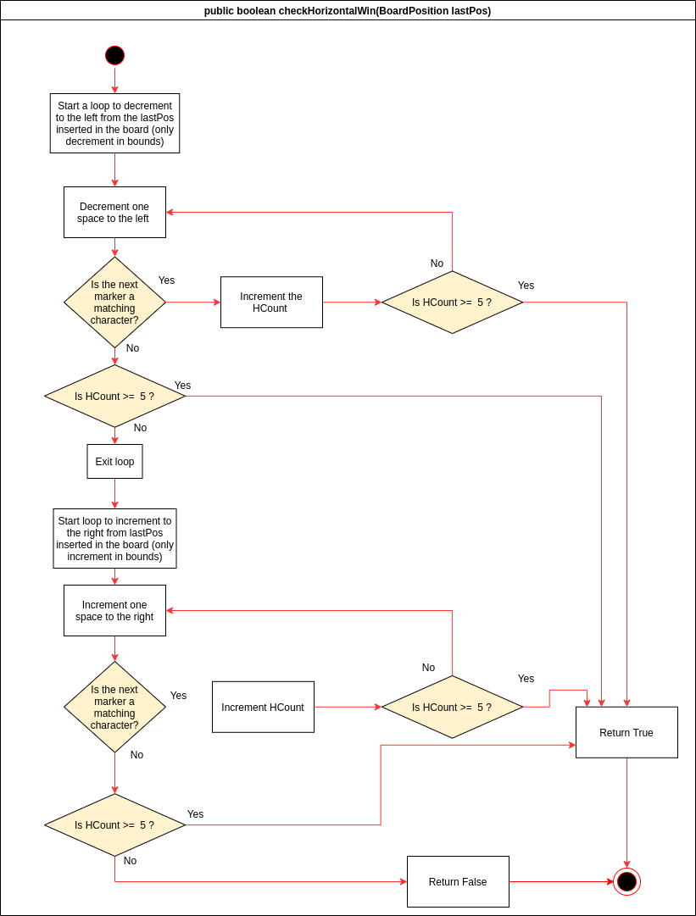
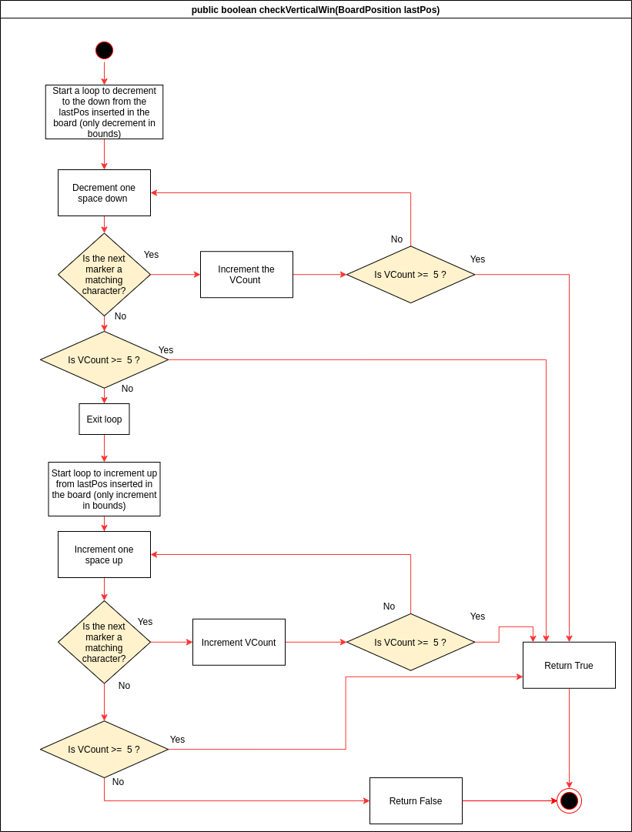
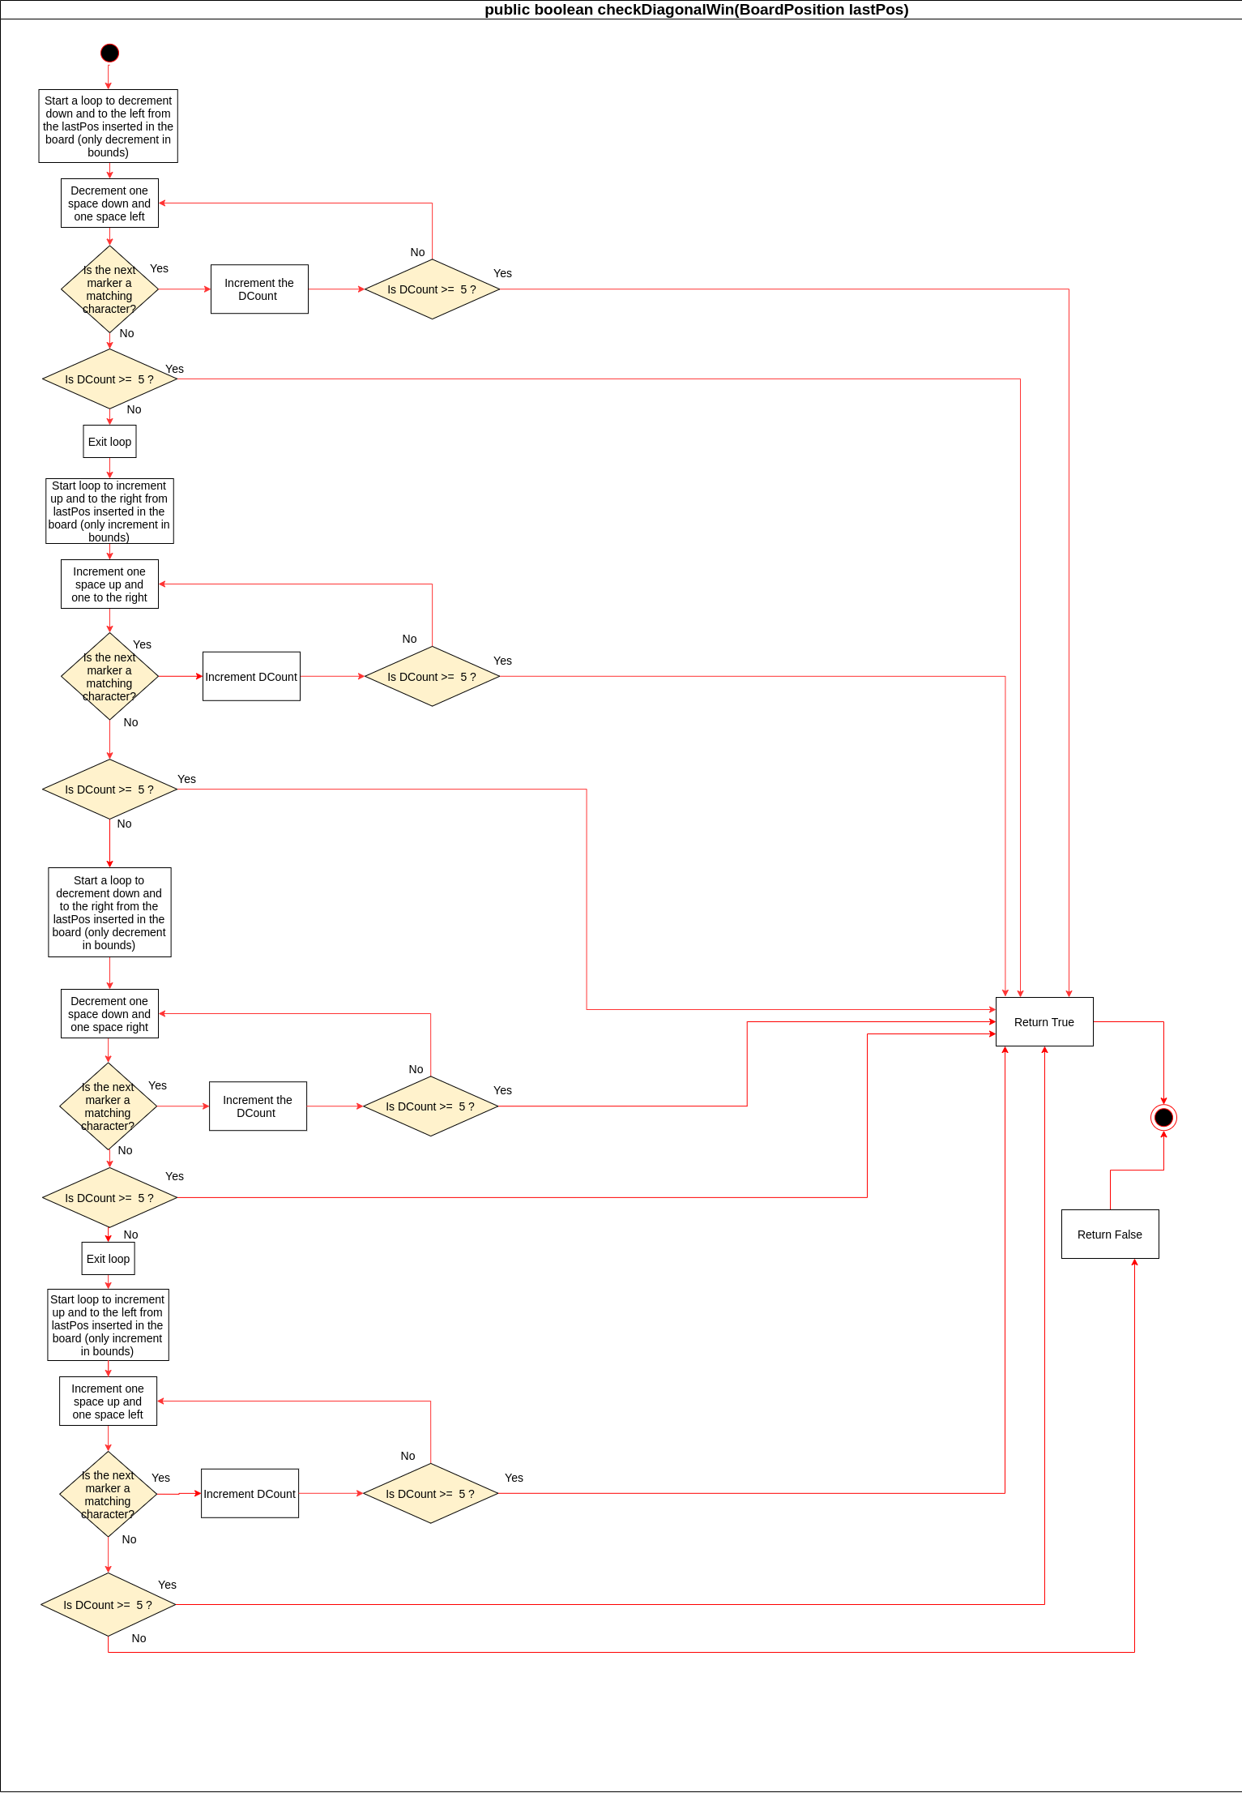

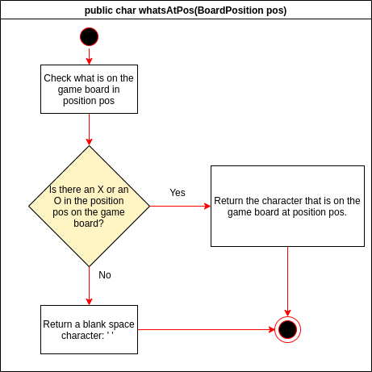
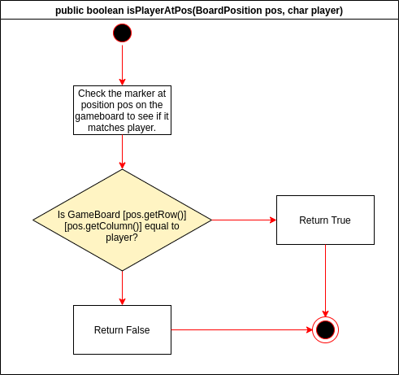
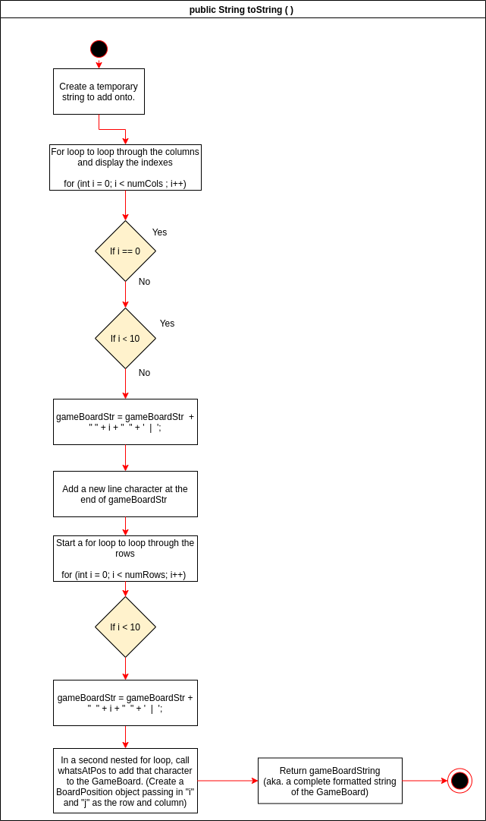

BoardPosition.java
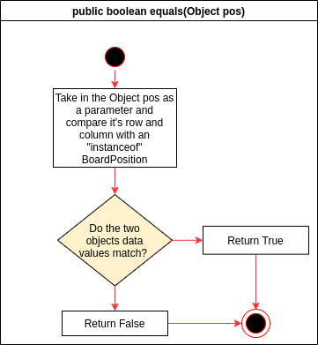
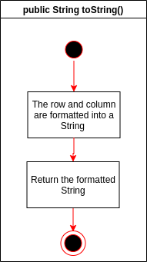

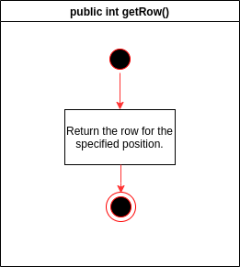
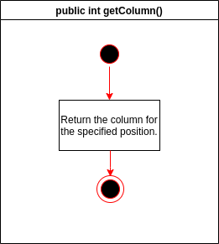

UML Class Diagrams
